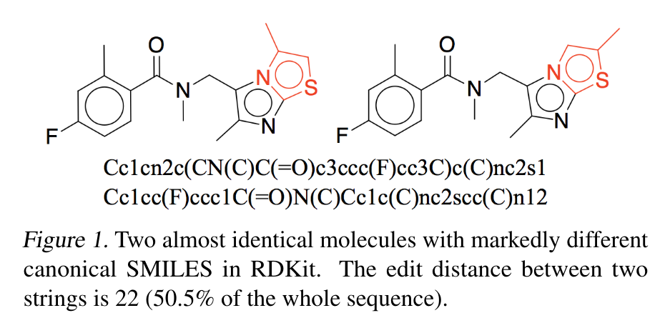

Minimal DFS codes:

[[ 0, 1, 6, 0, 6], [ 1, 2, 6, 0, 7], [ 2, 3, 7, 0, 6],

[ 3, 4, 6, 0, 6], [ 4, 5, 6, 2, 6], [ 5, 6, 6, 0, 6],

[ 5, 7, 6, 2, 6], [ 7, 8, 6, 2, 6], [ 8, 9, 6, 0, 9],

[ 8, 10, 6, 2, 6], [10, 11, 6, 2, 6], [11, 4, 6, 2, 6],

[ 3, 12, 6, 1, 8], [ 2, 13, 7, 0, 6], [ 0, 14, 6, 2, 6],

[14, 15, 6, 0, 6], [14, 16, 6, 2, 7], [16, 17, 7, 2, 6],

[17, 18, 6, 2, 7], [18, 0, 7, 2, 6], [18, 19, 7, 2, 6],

[19, 20, 6, 2, 6], [20, 21, 6, 0, 6], [20, 22, 6, 2, 16],

[22, 17, 16, 2, 6]]

and

[[ 0, 1, 6, 0, 6],[ 1, 2, 6, 0, 7],[ 2, 3, 7, 0, 6],

[ 3, 4, 6, 0, 6],[ 4, 5, 6, 2, 6],[ 5, 6, 6, 0, 6],

[ 5, 7, 6, 2, 6],[ 7, 8, 6, 2, 6],[ 8, 9, 6, 0, 9],

[ 8, 10, 6, 2, 6],[10, 11, 6, 2, 6],[11, 4, 6, 2, 6],

[ 3, 12, 6, 1, 8],[ 2, 13, 7, 0, 6],[ 0, 14, 6, 2, 6],

[14, 15, 6, 0, 6],[14, 16, 6, 2, 7],[16, 17, 7, 2, 6],

[17, 18, 6, 2, 7],[18, 0, 7, 2, 6],[18, 19, 7, 2, 6],

[19, 20, 6, 0, 6],[19, 21, 6, 2, 6],[21, 22, 6, 2, 16],

[22, 17, 16, 2, 6]]

Example from <https://arxiv.org/pdf/1802.04364.pdf>

Junction Tree Variational Autoencoder for Molecular Graph Generation